APPROVAL BLOCK
ApprovalS | Title | SIGNATURE/DATE
Prepared By: | Sai Krishna Yarraguntla
Reviewed By: | Parbat Singh (Lead- Cloud Managed Service)
Approved By: | Abhilash Das (Practice Leader)

PURPOSE
Mail trigger on every successful S3 backup with Hostname and file size details.
The Amazon S3 notification feature enables you to receive notifications when certain events happen in your bucket.

Pre-requisite
Need AWS account and create a user and access credentials. After that give access to that user S3 full access and SNS full access to create S3 bucket and SNS topic. Now need a Gmail to get the notification and accept the confirm subscription in your Gmail.

Precautionary:
Need to block the public access is enable to S3 bucket objects for security.

PROCEDURE:
Create s3 bucket
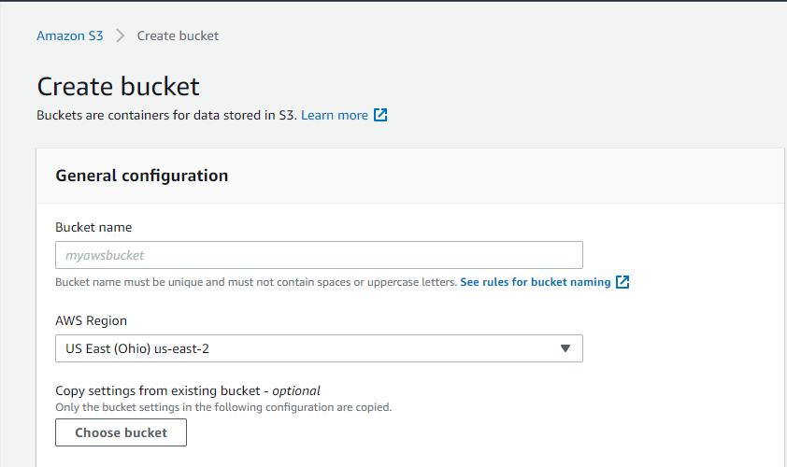
Now create SNS Topic
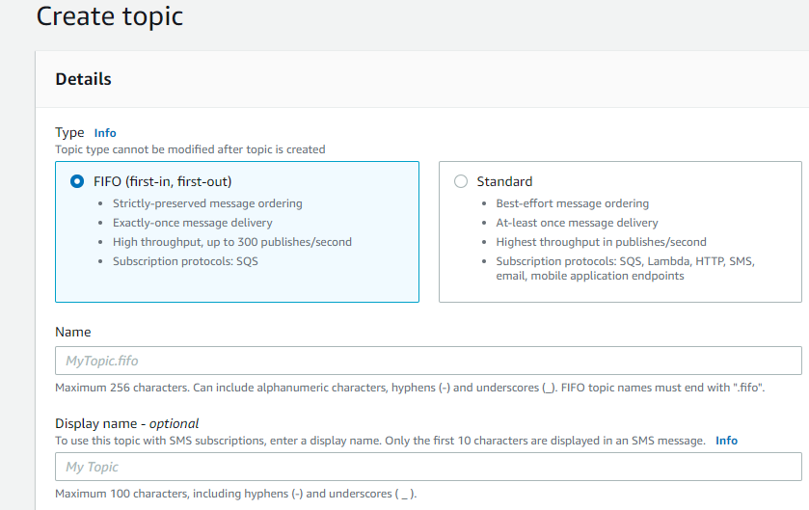
Now Go to the subscriptions and create a subscription of the newly created topic
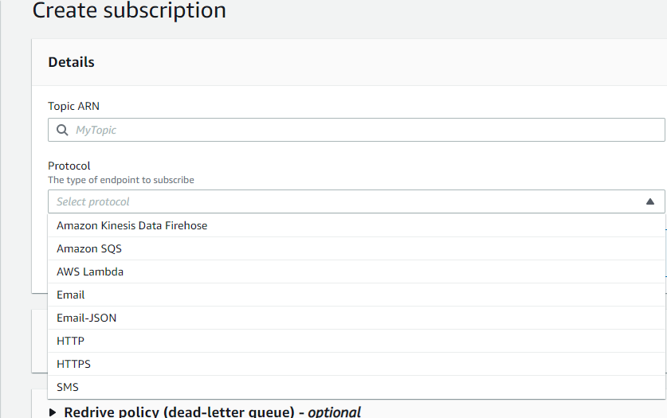

Now select the newly created topic ARN and click on Protocol and select Email for the notification and give your Gmail and confirm subscription in your Gmail.
Now go to Newly created topic and click on access policy
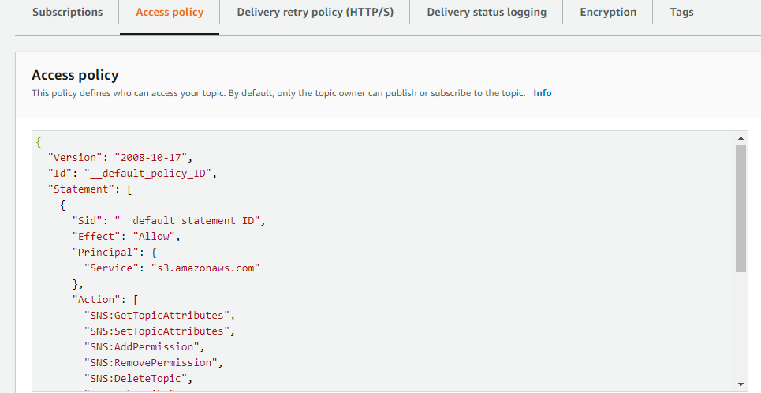
And edit the policy
Granting Permissions for S3 to Publish Messages to an SNS Topic
IAM policy that needs to be attached to the destination SNS topic
Now give the SNS ARN and S3 bucket ARN here.
{
"Version": "2008-10-17",
"Id": "example-ID",
"Statement": [
{
"Sid": "s3-event-notifier",
"Effect": "Allow",
"Principal": {
"Service": "s3.amazonaws.com"
},
"Action": [
"SNS:Publish"
],
"Resource": "<UPDATE-YOUR-SNS-ARN-HERE>",
"Condition": {
"ArnLike": {
"aws:SourceArn": "arn:aws:s3:*:*:<UPDATE-YOUR-BUCKET-NAME-HERE>"
}
}
}
]
}

Now go to S3 bucket and click on the newly created bucket and click on properties go to event notifications and select that and create event notification.
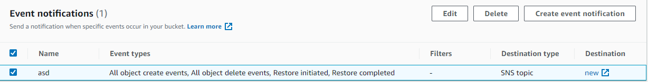
Now give event name
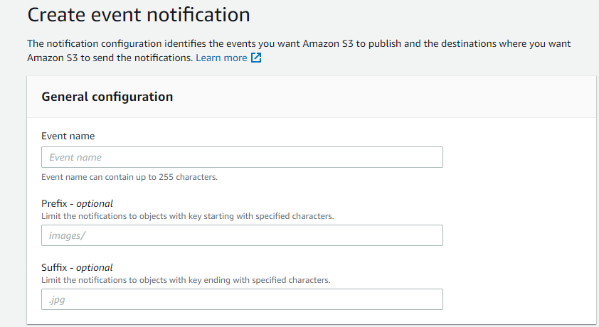
Now select the required event types here
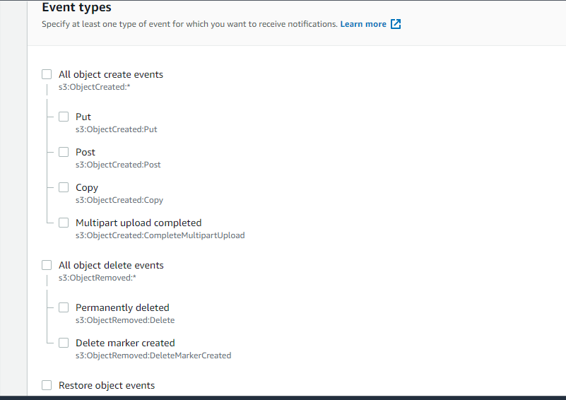
And now give Destination to SNS topic
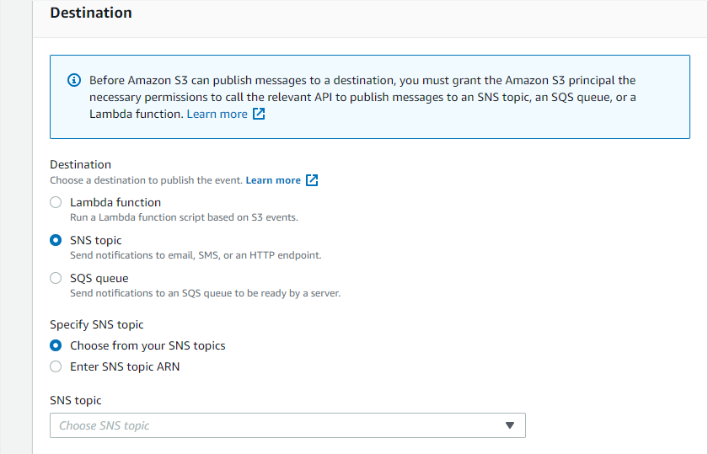

Here to select SNS topic and specify the newly created SNS topic after that click on save changes.
Now if any action is happened on this bucket like create object or delete object it will give a notification to your email and give all the information about the object like size of the file.

